SOCKET PROGRAMMING
24BD1A0517
First we need to compile both the SimpleServer.java and SimpleClient.java. Then run first SimpleServer.java in one terminal and SimpleClient.java in other terminal
First Terminal
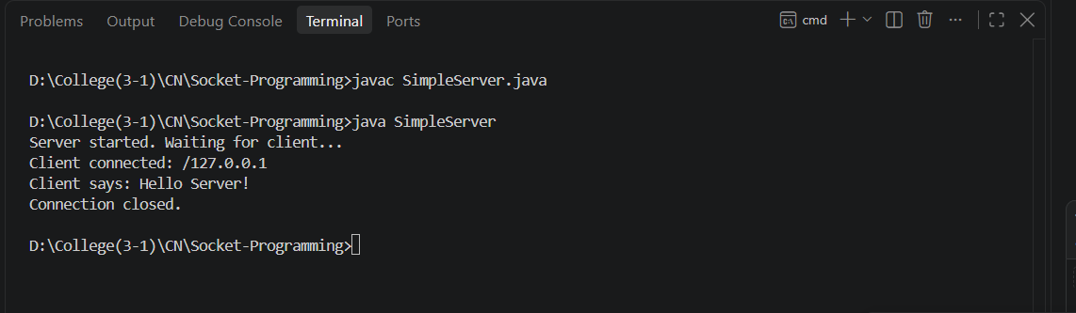
Second Terminal
